GUÍA DE APRENDIZAJE 4 : INGLES Nivel .2 A-B-C-D-E

Docente: MRS.Dorys GONZALEZ PONCE

Estimado alumno, debido a las actuales circunstancias y hasta que la situación se normalice, te invitamos a trabajar desde tu casa, leer esta guía e ir respondiendo las actividades propuestas. Es de suma importancia evidenciar lo que vas aprendiendo y las dudas que surjan de tu trabajo.
El objetivo de esta actividad es lograr que adquieras conocimientos y habilidades primordiales para afrontar tu siguiente desafío: el año 2020.
Envía tus respuestas y dudas al correo:_gonzalez.dorys@gmail.com_ Muchas gracias.

Nombre
Curso
Correo electrónico
Fecha

Globalization

Objetivo: Demostrar capacidad para resolver los ejercicios de forma eficiente

Instrucción: Leer ,contestar guía y luego pegarla en su cuaderno

1.- Translate the following verbs from the list into Spanish

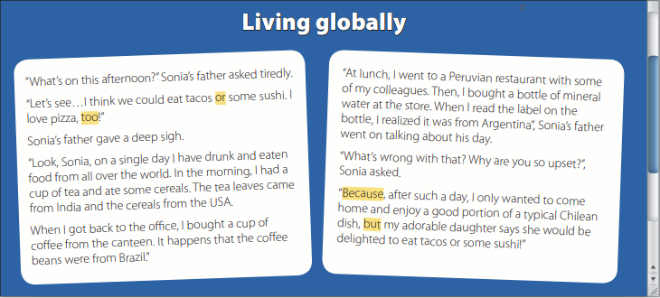

7

Present | Past | Past articiple | Meaning
Ask | Asked | Asked
See | Saw | Seen
Think | Thought | Thought
Give | Gave | Given
Look | Looked | Looked
Have | Had | Had
Drink | Drank | Drunk
Eat | Ate | Eaten
Get | Got | Gotten
Buy | Bought | Bought
Go | Went | Gone
Read | Read | Read

2.- Answer the following questions

1. Why is Sonia’s father so disappointed?

__________________________________________

2. Where did the mineral water come from?

__________________________________________

3. What did he have in the morning?

__________________________________________

4. What does Sonia want to eat?

__________________________________________

5. When did he eat Peruvian food?

____________________________________________________________________

3. Complete the Word Search Puzzle with the verbs in infinitive form
