GUÍA DE APRENDIZAJE 3 INGLES nivel : 2 MEDIO A.B-C.D-E

Docente: Dorys Gonzalez PONCE

Estimado alumno, debido a las actuales circunstancias y hasta que la situación se normalice, te invitamos a trabajar desde tu casa, leer esta guía e ir respondiendo las actividades propuestas. Es de suma importancia evidenciar lo que vas aprendiendo y las dudas que surjan de tu trabajo.
El objetivo de esta actividad es lograr que adquieras conocimientos y habilidades primordiales para afrontar tu siguiente desafío: el año 2020.
Envía tus respuestas y dudas al correo : GONZALEZ.DORYS@GMAIL.COM Muchas gracias.

Nombre
Curso
Correo electrónico
Fecha

Globalization

Objetivo: Demostrar comprensión de ideas generales e información explícita en textos adaptados y auténticos simples.
Indicadores .1 de la unidad
Eje :Comprensión Lectora

Instrucción: Leer ,contestar guía y luego pegarla en su cuaderno

READING HANDOUT :

Globalization describes the process by which regional economies, societies, and cultures have become integrated through a global network of communication, transportation, and trade. The term is sometimes used to refer specifically to economic globalization: the integration of national economies into the international economy through trade, foreign direct investment, capital flows, migration, and the spread of technology. However, globalization is usually recognized as being driven by a combination of economic, technological, sociocultural, political, and biological factors. The term can also refer to the transnational circulation of ideas, languages, or popular culture through acculturation.

I. - Write the meaning of the following sentences in Spanish.(escribe el significado de las siguientes en español).

Network = through = c.-trade=

Investment = capital flow = trade =

However = usually = the term =

Foreign = have become = foreign =

II.- true or false

1 ____ Are regional economies integrated through a network of communication

2 ____ Capital Flows and migration are not part of the economic globalization

3 ____ Globalization is recognized by economic factors

4 ____ Sociocultural and Political are not factors of globalization

5 ____ The term is also refer to the transnational circulation of ideas

III
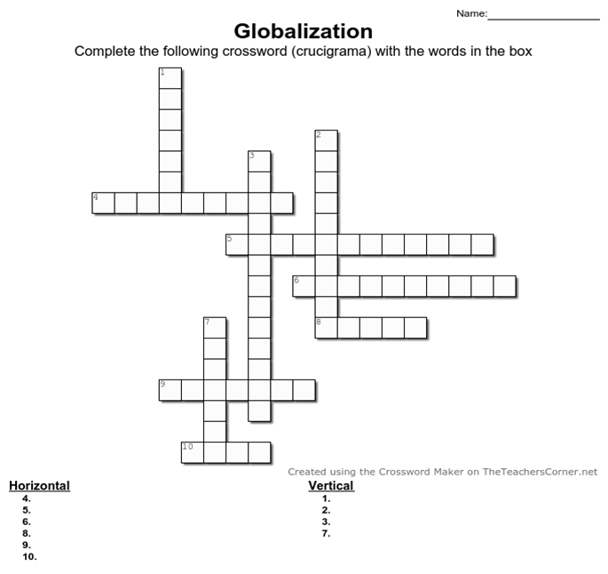

Network – Investment – Capital Flow- Trade – Term – Technology – Migration – Popular – Culture – Globalization

Recuerda enviar tus dudas y respuestas al correo ______________
Muchas gracias.

