 | CORONAVIRUS.
Name
Grade: Terceros Medios 2020 |  | Date Mayo 2020
Objective: Comprender lectura real, de interés mundial, utilizando conocimientos previos de la texto.
Teacher . Miss Patricia Jara Céspedes
- Instructions: Read the text and then answer the questions.
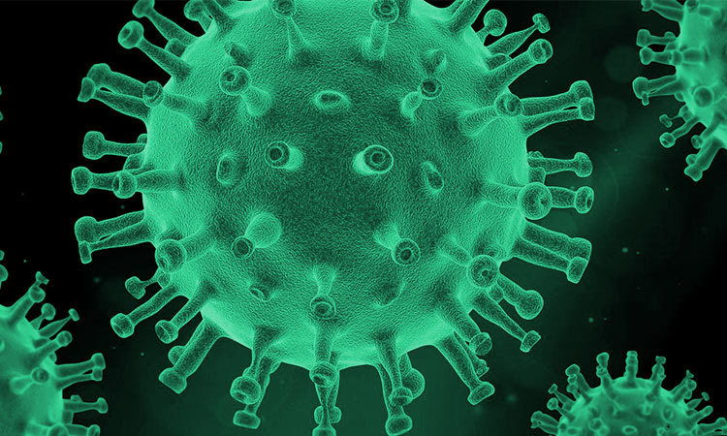
Nations around the world are battling with a major outbreak of a new deadly virus. The coronavirus, which started in the Chinese city of Wuhan, on 22nd January 2020 has already killed around the 3.000 people from around the world. Countries affected include China, America, the UK and Italy. It has also spread to many other places like Pakistan, Japan, Korea, and Thailand . More than 90.000 cases of people have caught the virus and are in hospitals. The World Health Organisation (WHO) has declare that this is a global health emergency. China has been on lookdown for many weeks and people have not been to work, school and all public transport has been suspended. In other countries schools have been closed and People have been told no to travel.

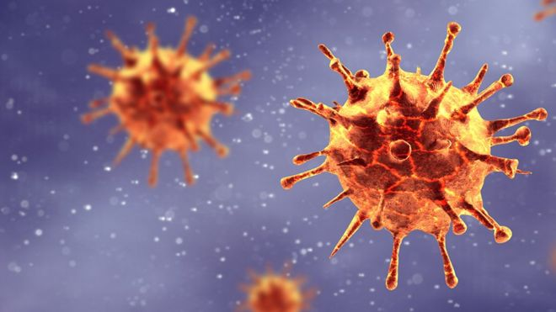
The new coronavirus is suspected to have come from illegally traded animals is a Wuhan market. The virus mutated and spread from an animal to a human. There are fears it could mutated and spread further. Scientist say the virus is contagious and can be passed from person to person through the air. Dr. Linfa Wang, a virologist at the Duke-National University of Singapure, said the new coronavirus is in the same family as SARS, but it´s different from sars. He said People needed to llok for pneumonia-like symptons, such as fever, caugh and difficulty breathing. Fu Ning, a 36 years old woman from Beijing, said: “I feel fearful because there´s no cure for the virus”.

- EVALUATION: ¿HOW MUCH DO YOU UNDERSTAND? DEVELOP DE FOLLOWING ACTIVITIES DEMOSTRATING WHAT UNDERSTAND.
ACTIVITY 1: ANSWER QUESTION ABOUT THE READING
1. Which country did the virus come from? …………………………………………………………………………..
2. On what day did the virus start? ………………………………………………………………………………………..
3. Name two countries affected by the virus? ..……………………………………………………………………..
4. How many people have been in hospital because of the virus? .…………………………………………..
5. Where is the virus suspected to have come from? ………………………………………………………………..
6. How is the virus passed from person to person? .………………………………………………………………..
II. Match the words to their meanings:
 | Words | ¿???????? |  | Meanings
1 | Cough |  | A | Can be passed on easily by physical contact
2 | Fever |  | B | To release air from the mouse with a sharp sound
3 | Virus |  | C | Forbidden by law and is a criminal act
4 | Bacteria |  | D | Bacteria that causes infection and makes us sick
5 | Contagious |  | E | A desease spread all around the world.
6 | Ilegal |  | F | To reléase air from the nose
7 | Cure |  | G | Lots of small germs
8 | pandemic |  | H | To have a high body temperature
9 | Hospital |  | I | A place you go when you are sick
10 | smeeze |  | j | To stop or relieve an illness

III. COMPLETE THE WORD SEARCH.
B | O | I | S | C | I | Q | P | Z | B | F | C | H | S | D
N | S | I | O | I | C | O | N | T | A | G | I | O | U | S
Q | E | U | D | W | M | K | W | D | I | F | M | S | N | J
P | G | K | F | E | Z | E | E | N | S | A | E | P | M | N
H | I | B | L | D | L | J | E | U | P | W | D | I | A | T
P | L | A | G | E | L | L | I | B | I | V | N | T | M | C
Z | Q | M | V | G | M | F | V | K | E | Z | A | A | A | G
A | H | W | X | Z | A | Q | A | I | U | V | P | L | V | G
Y | G | S | B | S | X | N | I | C | Z | V | I | R | U | S
X | Q | D | J | O | S | I | I | J | E | R | U | C | S | S
F | H | Q | H | D | D | O | D | M | T | M | P | H | G | E
O | A | K | S | A | T | T | L | J | A | E | Z | M | I | N
N | G | V | H | M | G | F | G | A | J | L | M | X | I | O
X | J | N | E | Z | F | E | V | E | R | I | S | Z | L | R
W | S | Y | U | K | G | P | C | A | E | Z | T | B | Q | E

ENGLISH | SPANISH | ENGLISH | SPANISH
1 |  | 6
2 |  | 7
3 |  | 8
4 |  | 9
5 |  | 10

- NOW, ACCORDING YOUR GRADE ANSWER THE FOLLOWING QUESTIONS
- 3 A/B
1. WHAT ARE CONDUCTORS AND INSULATORS? …………………………………………………………………………… 2. WHAT ARE 5 GOOD CONDUCTORS? ..…………………………………………………………………………………………
- 3C
1. WHAT DOES GEAR MEAN? …..……………………………………………………………………………………………………
2. WHAT ARE THE FOUR TYPES OF GEARS? …………………………………………………………………………………..
- 3D/E
1. WHAT ARE THE FOUR TYPES OF WELDING? ………………………………………………………………………………
2. WHAT IS THE EASIEST METAL TO WELD? ..……………………………………………………………………………………
- 3F
1. HOW WOOD IS MANUFACTURED? ……………………………………………………………………………………………..
2. WHAT ARE THE 3 TYPES OF WOOD? ……………………………………………………………………………………………

- 3H
1. WHAT IS THE DIFFERENCE BETWEEN ARTISTIC DRAWING AND TECHNICAL DRAWING?...……………
2. WHAT ARE THE TYPES OF TECHNICAL DRAWING? ……..………………………………………………………………..

- 3G
1. WHAT IS THE MEANT BY DRAINAGE SYSTEM?..................................................................................
2. HOW DOES A DRAINAGE SYSTEM WORK? …………………………………………………………………………………...

PD. Remember, send your answers to; profepatingles20@gmail.com

