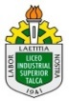
GUÍA DE APRENDIZAJE (1) ASIGNATURA O MÓDULO INGLES NIVEL TERCEROS MEDIOS

Departamento o docente(s): PATRICIA JARA CESPEDES

Estimado alumno, debido a las actuales circunstancias y hasta que la situación se normalice, te invitamos a trabajar desde tu casa, leer esta guía e ir respondiendo las actividades propuestas. Es de suma importancia evidenciar lo que vas aprendiendo y las dudas que surjan de tu trabajo.
El objetivo de esta actividad es lograr que adquieras conocimientos y habilidades primordiales para afrontar tu siguiente desafío: el año 2020.
Envía tus respuestas y dudas al correo profepatingles@gmail.com Muchas gracias

Nombre
Curso | Tercero Medio ………………
Correo electrónico
Fecha | Mayo 2020

Across cultures
Comprensión lectora.

Objetivo: Leer, comprender, e interpretar textos breve y simples relacionadas a otras rutinas y vida social de diferentes culturas.

Reading 1: Maria Santini is from Naples in Italy, Her mother and father aren¨t from Naples. They are from Milan, in the north of Italy. Maria´s mother is a housewife and her father is a dentist. Maria´s a student. Her brother and her sister are Teacher. They´re English teachers! Their school is in a small Street near their house . Maria´s favourite animal is Babylon, her dog, and her favourite filmstar is Keanu Reeves.
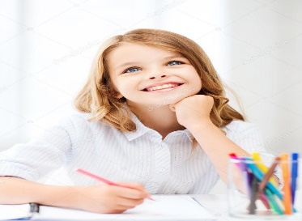
Activities:

I.- Are theses statements TRUE OR FALSE.? (¿son estas oraciones verdaderas o falsas?)
Escriba T para verdadero y F para falsa.

1. Maria is Italian________
2. Maria´s father is a dentist ______
3. She´s from Roma ______
4. Her brother and sister are English teaches _____
5. Her mother and father are from Naples______
6. Her favourite animal is Keanu Reeves.

II. Imagine you are Maria´Santini. Write about yourself and your family .
…………………………………………………………………………………………………………………………………………………………
…………………………………………………………………………………………………………………………………………………………
…………………………………………………………………………………………………………………………………………………………
…………………………………………………………………………………………………………………………………………………………
…………………………………………………………………………………………………………………………………………………………
…………………………………………………………………………………………………………………………………………………………
……………………………………………………………………………………………………………………………………………………………………………………………
…………………………………………………………………………………………………………………………………………………………………………………………...

III. Vocabulary: Puzzle time! What are these words?

1.- Prtgl ___________________________ 7.- Trksh ________________________________
2.- cmptr __________________________ 8.- engnr ________________________________
3.- studt __________________________ 9.- dlphn ________________________________
4.- dctr ____________________________ 10 Grk __________________________________
5.- sstr_____________________________ 11 phtgrph _______________________________
6.- Argntnn _________________________ 12 dnnr __________________________________

((Example: 1 Portugal.))

Reading 2: MEET OUR READERS.

Mac is from Minnesota, in the United States. He´s sixteen years old and lives with his mother, father and two sisters. Every day he goes to school, has lessons, meets his Friends and watches TV. He does all the things that boys of sixteen do. But Mac is not an ordinary boy of sixteen. He is the junior basketball Champion of Minnesota.
On school days he gets up early, at 6,30. He has breakfast with his mother in the kitchen and then he goes to the Sports centre. He swims there until 7,30 and then goes to school. At school. At school he has the usual lessons, (English, Math, etc.), but in the afternoons, after school, he has sports training,
At the weekend he plays basketball, ¡of course! He plays on Saturdays and on Sunday. Mac It´s a difficult life, but Mac loves it because he loves basketball. His favourite players are the Chicago Bulls.
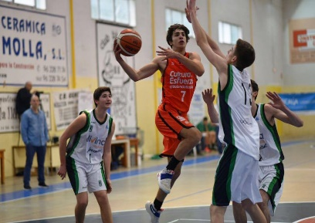

Activity: Reading and writting.
I . Read the text about Mac. Now use these promps to write and interview with Mac.

a. You: Where/from. Where are you from?
Mac: I´m from Minnesota, in the USA.
b. You: How many/People/family?
………………………………………………………………………………….
Mac: ………………………………………………………………………….
c. You: What time/ get up/ Tuesdays?
………………………………………………………………………………….
Mac: …………………………………………………………………………
d. You: Have breakfast/with/sisters?
………………………………………………………………………………...
Mac: ...………………………………………………………………………
e. You: What time/school/start?
………………………………………………………………………………….
Mac: ………………………………………………………………………….
f. You: Do/ afternoons?
…………………………………………………………………………………..
Mac: …………………………………………………………………………..
g. you: Do/weekends?
…………………………………………………………………………………..
Mac: …………………………………………………………………………….

Recuerda enviar tus dudas y respuestas al correo profepatingles@gmail.com

Muchas gracias.

GUÍA DE APRENDIZAJE (2) ASIGNATURA O MÓDULO INGLES NIVEL TERCEROS MEDIOS

Departamento o docente(s): PATRICIA JARA CESPEDES

Estimado alumno, debido a las actuales circunstancias y hasta que la situación se normalice, te invitamos a trabajar desde tu casa, leer esta guía e ir respondiendo las actividades propuestas. Es de suma importancia evidenciar lo que vas aprendiendo y las dudas que surjan de tu trabajo. El objetivo de esta actividad es lograr que adquieras conocimientos y habilidades primordiales para afrontar tu siguiente desafío: el año 2020.
Envía tus respuestas y dudas al correo profepatingles@gmail.com Muchas gracias

Nombre
Curso | Tercero Medio ………………
Correo electrónico
Fecha | Mayo 2020

Comprensión Lectora

Objetivo: Predecir el tema del texto, localizar información general, discriminar el tipo de texto, reconocer información específica, sintetizar las ideas centrales de cada párrafo.

TEXT: ELECTRICITY: THE FORCE THAT TRANSFORMED DE WORLD.

In order to talk about electricity, it is necessary first to talk about the atom. The idea of the “atom” has a long history, one extending back to about 600 B.C. and the time of the Anciente Greeks. They believed that all matter was made up of “atoms”, which means “indivisible”. It was no until 1897 that it was discovered that the atom was not indivisible but is composed of even smaller particles. Among these particles is one called the electron. Electrons orbit around the center nucleous of the atom, much as the planets in the solar system orbita round the sun. Electrons closer to the nucleous are held more tightly than those of the outer orbits. It is the electron in the outermost orbit of certain kinds of atoms that can be made to flow as electric current. Electrons flow easily through certain kinds of materials called “conductors”. Many metals, such as silver, copper, gold, and aluminium are good conductors. Good conductors are used in electric circuits to provide a path for the current.
Other substances provide strong resistance to the flow of current. These substances are called “insulators”, which are used to confine a current to the desired path.
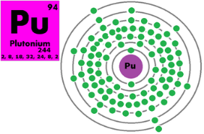ATOM, representation of an atom of plutonium
Substances such as a rubber, glass, wax, and certain kinds of plastic are good insulators. Thus, the cord of an electric appliance consists of a piece of wire, generally copper, surrounded by a type of plastic or vinyl, which is the insulator confining the current to its path.
The pressure that makes electrons flow along Wires is called “voltage”. Voltage may be created by the generator at a power plant or by an electric battery. When you turns on a light or an electric appliance, electrons are drawn from a generator at a power plant. When you turn the light or appliance off, there will be pressure or voltage built up at the switch, but no current will flow. It is somewhat similar to the way a water system works.
When you turn on a faucet, water flows through Wires, When you turn off a faucet, water pressure remains but no water flows through the faucet. Similarly, when you turn off an electric appliance, voltage remains, but no current flows. In a water system, the whole operation depends on water pressure generated by a water pump. In an electric system, the generator (or battery) creates the pressure called voltage.
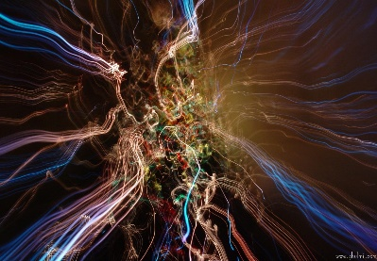

Activities:

I.- Cree una lista en ingles de los artefactos electrodomésticos que usan en sus hogares o en general en la vida diaria.
…………………………………………………………………………………………………………………………………………………………
…………………………………………………………………………………………………………………………………………………………
…………………………………………………………………………………………………………………………………………………………

II.- Destacar/escribir la presencia de elementos cognados en la lectura, que harán más fácil la tarea de comprensión a pesar
de su extensión.
…………………………………………………………………………………………………………………………………………………………
…………………………………………………………………………………………………………………………………………………………
…………………………………………………………………………………………………………………………………………………………
…………………………………………………………………………………………………………………………………………………………
…………………………………………………………………………………………………………………………………………………………
III.- Vuelva a leer párrafos 4 y 5 ubicando y subrayando ejemplos de:
Conductores: …………………………………………………………………………………………………………………………………………………………
…………………………………………………………………………………………………………………………………………………………
Aislantes :………………………………………………………………………………………………………………………………………………………
…………………………………………………………………………………………………………………………………………………………
Iv.- Vuelva a leer texto para completar oraciones representativas.

1. Electrons are smaller parts of ______________________
2. Plastic and rubber are good ________________________
3. Electric cords consist of ____________________________
4. Electrons are drawn from a ________________ at a _______________
5 Electric current flow through ___________________________________
6. Turn off an electric device, voltage ___________________ , but no _______________ flow
7. Some substances provide strong ______________ to the flow of current.
8. It was discoved that the atom was not _____________________
9.Electrons orbit around the _________________

V.- Escriba verdadero o falso a las siguientes oraciones. Escriba “t” (verdadero) “f” (falso)

1.- Atoms means divisible _______________
2.- Electrons flow hardly through certain kinds of materials_____________
3. Resistance is the same as insulators ______________
4.- Planets orbits as the same as the atom around the sun ___________
5.- Electric current flow through cords ____________
6.- Voltage is created by the water pressure ______________

VI.- Responder preguntas para verificar comprensión del texto.

1. What are conductors?
…………………………………………………………………………………………………………………………………………………………
2. What are insulators?
…………………………………………………………………………………………………………………………………………………………
3. Where does de word “atom” come from?
…………………………………………………………………………………………………………………………………………………………
4. What are atoms compared with?
…………………………………………………………………………………………………………………………………………………………
5. what is the function of a cord in an electric appliance?
…………………………………………………………………………………………………………………………………………………………
6. How is made of the voltage?
…………………………………………………………………………………………………………………………………………………………
7. How is created de voltage? Explain briefly.
…………………………………………………………………………………………………………………………………………………………
8. What occur when you turn on or turn off an appliance?
…………………………………………………………………………………………………………………………………………………………
VII. Con la ayuda de texto, realizar un diagrama de una de los dos procesos descritos: Turn on a light and Turn on a water faucet.

Recuerda enviar tus dudas y respuestas al correo profepatingles@gmail.com

Muchas gracias.

